**BIG DATA LAB**

**P.SESHA HARSHINI**

**1NT19IS107**

**C1 BATCH**

3. Use the Hadoop framework to write a custom MapReduce program to perform word count operation on a custom data set .

Right click on project (Mapreduce)

Click on -> build a path -> add external archives -> Hadoop 3.2.1 -> share

In share 1. Click on common ->open hadoop-common-3.2.1.jar

2. Click on mapreduce -> open hadoop-mapreduce-client-core-3.2.1.jar

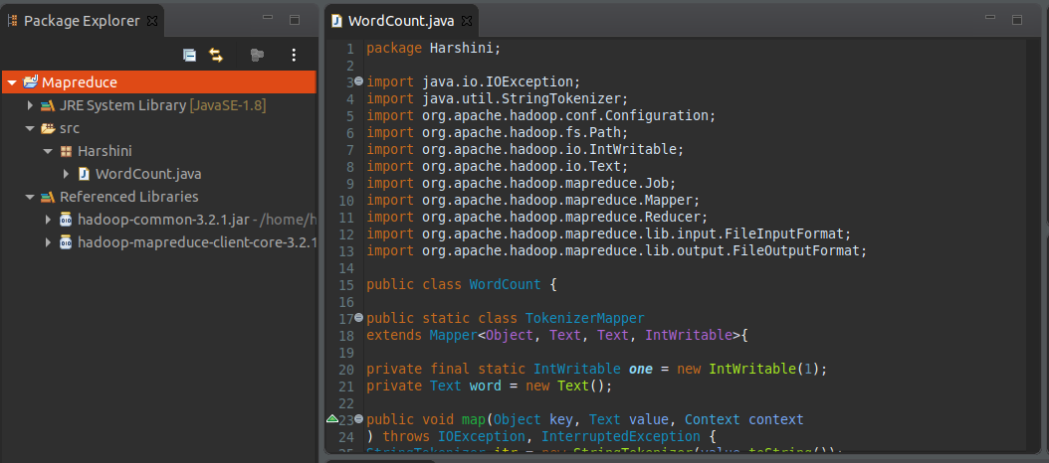

Right click on project -> export -> java -> jar file -> next

Browse the address of the java file and save it in desktop/document/downloads and name it (1NT19IS107_Harshini.jar)

cd $HADOOP_HOME

cd sbin

jps

start-all.sh

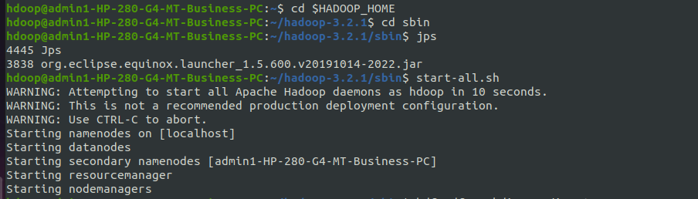

hdfs dfs -mkdir -p ~ /input

hdfs dfs -appendToFile - ~/input/txt.txt

Ctrl+d (2 times).



hadoop jar /home/hdoop/Desktop/1NT19IS107_Harshini.jar ~/input ~/harshini

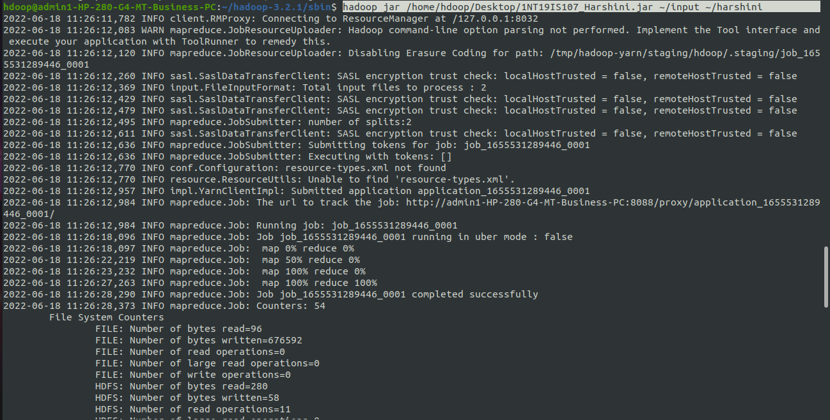

hdfs dfs -cat ~/harshini/part*

